**Daily Scrum or Standup Meeting**

Team name: Alpha Squad

Scrum Master: Isaak Johnson

Date: Nov 12

|  |  |  |  |
| --- | --- | --- | --- |
| **Team Member** | **What did you do since the last scrum?** | **What do you plan to do before the next scrum?** | **What obstacles do you have?** |
| Alex Beeston | completed the last bit of functionality for the live auction (user sees the list of upcoming items, and the admin can update the winning price/bid on each item) from help with Ben and Joey. | Write unit tests for the live items | need to decide which unit tests to write and learn how to implement them. |
| Joey Carlisle | did the update password, worked on the file upload | unique user id’s work on testing | learning how and when to unit test |
| Isaak Johnson | Nothing | Finish writing unit tests for the silent page | Need to do more research for writing unit tests. |
| Ben Taylor | Began writing unit tests for the users view. | Finish writingunit tests for users view and payment view and work on stories focused on these 2 pages. | None at this time. |

# Burndown

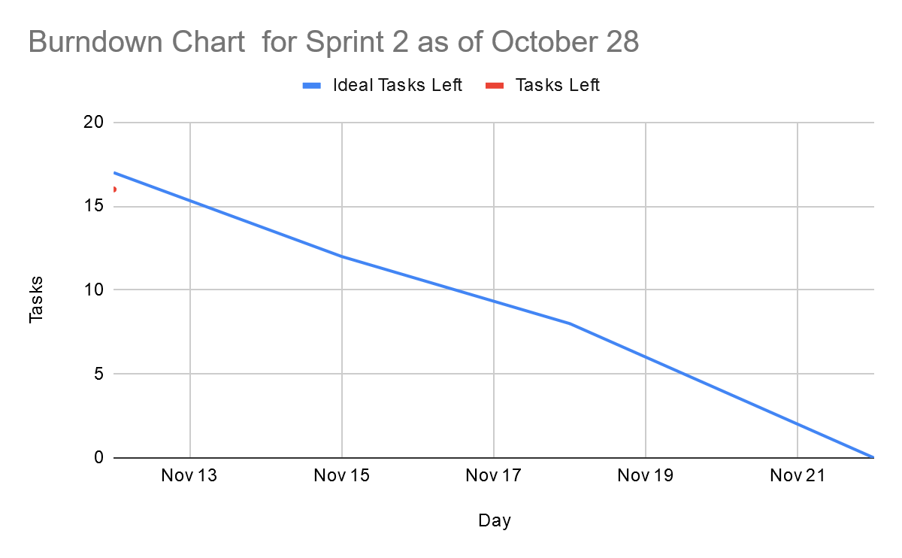

# Screenshot of you project board

